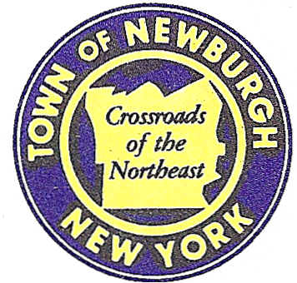

TOWN OF NEWBURGH
_______Crossroads of the Northeast __________________________
OLD TOWN HALL
308 GARDNERTOWN ROAD NEWBURGH, NEW YORK 12550

PLANNING BOARD
JOHN P. EWASUTYN, CHAIRMAN
TELEPHONE 845-564-7804
FAX 845-564-7802
E-MAIL: planningboard@townofnewburgh.org

PLANNING BOARD AGENDA

November 3rd, 2016

*PLEASE NOTE: The Planning Board Meeting will start at 7:00 P.M. and all Applicants/Representatives
are to be present at that time. The Meeting will be held in the Meeting Room of Town Hall,
located at 1496 Route 300, Newburgh NY.*

1. Lakeside Senior Housing (16-19) INITIAL APPEARANCE
21 Lakeside Road CONCEPT SITE PLAN (102 UNITS)
Section 86, Block1, Lot 39.22 & 39.23
Zone: 1B
Rep: Medenbach and Eggers
4305 US Highway 209
Stone Ridge, NY 12484

2. Sarvis, LLC (16-09) LOT LINE
1 Balmville Rd. & 2 Stern Drive
Section 84, Block 5, Lot 34 & 33
Zone: R-3
Rep: Talcott Engineering Design, PLLC.
1 Gardnertown Rd.
Newburgh, NY 12550

*WORK SESSION*
Project Readiness Discussion scheduled for 5:30 p.m. in the Meeting Room of
Town Hall on Thursday, November 3rd, 2016.*

PLANNING BOARD BUSINESS
WORK SESSION

1. All Granite (11-14) 6 month extension from November 3, 2016 to May 3, 2017.

2. Patton Ridge Subdivision (12-18) 6 month extension from November 3, 2016 to May
3, 2017.

*WORK SESSION*
Project Readiness Discussion scheduled for 5:30 p.m. in the Meeting Room of
Town Hall on Thursday, November 3rd, 2016.*

